 | Epsom & Ewell F.C.  v  Egham Town  Saturday, 3rd December 2011
For this afternoon’s Combined Counties League match, we welcome the players, officials and supporters of Egham Town, today's officials, and of course our own regular supporters to the Moatside. We also welcome back two players, Dale Marvell and Paul Borg, who have played a large part in our history over recent years, but I hope they don’t play too well today!

Egham were our final visitors last season, and despite them being the better side on the day, we were actually leading until the final kick of the game and had to settle for a 2-2 draw.

We were last here two weeks ago, when we recorded a solid 2-1 victory over Croydon. The match was very even for large parts of the game, but we upped our level a bit in the second half and deserved the win.

Then seven days ago we travelled to Stag Meadow, home of the newly formed Windsor F.C. and although we were defeated 1-0, I thought it was one of our better performances of the season against a team that had clearly strengthened since we drew 2-2 here in August.

We have a very big match in three days time when Sutton United visit us for a Surrey Senior Cup tie. It is the first time we have hosted them since 1985. We then travel to Chessington & Hook United next weekend and return here to play Cove the following Saturday. Finally, our League Cup tie against Worcester Park is now to be played on Saturday 7th January with the League match at South Park being moved back to the Tuesday.

Match, ball and player sponsorships are still available and the gaps to fill are shown later in the programme. A League match costs £35 to sponsor, compared to £40 for a player, and you also get free entry for two, including programmes and boardroom hospitality! If you have a business to advertise, or know someone who has, you can also get an advert for them in the programme too, so this represents excellent value for money.

Enjoy the game!

Richard

Cover photo this week by Gemma Jarman

Mark Jarman scores with a textbook header
against Croydon exactly two weeks ago.

Cherry Red Records Combined Counties League
Premier Division Table
inc Wednesday 30th November | P | W | D | L | F | A | Pts | GD
Guildford City | 19 | 13 | 5 | 1 | 52 | 21 | 44 | +31
Windsor | 19 | 11 | 6 | 2 | 52 | 19 | 39 | +33
Egham Town | 18 | 11 | 3 | 4 | 51 | 30 | 36 | +21
Camberley Town | 19 | 11 | 2 | 6 | 47 | 26 | 35 | +21
Hanworth Villa | 16 | 11 | 3 | 2 | 39 | 17 | 33** | +22
Horley Town | 19 | 9 | 4 | 6 | 38 | 25 | 31 | +13
South Park | 18 | 9 | 4 | 5 | 32 | 22 | 31 | +10
Badshot Lea | 20 | 9 | 3 | 8 | 33 | 34 | 30 | -1
Dorking | 19 | 9 | 2 | 8 | 28 | 31 | 29 | -3
Molesey | 17 | 8 | 3 | 6 | 36 | 29 | 27 | +7
Wembley | 17 | 7 | 6 | 4 | 36 | 29 | 27 | +7
Epsom & Ewell | 19 | 7 | 4 | 8 | 30 | 33 | 25 | -3
Farnham Town | 18 | 5 | 6 | 7 | 27 | 29 | 21 | -2
Sandhurst Town | 18 | 7 | 0 | 11 | 28 | 38 | 21 | -10
Colliers Wood Utd | 20 | 6 | 3 | 11 | 35 | 46 | 21 | -11
Raynes Park Vale | 18 | 6 | 3 | 9 | 31 | 42 | 21 | -11
Banstead Athletic | 20 | 5 | 5 | 10 | 25 | 53 | 20 | -28
Ash United | 20 | 5 | 4 | 11 | 30 | 43 | 19 | -13
Cove | 19 | 5 | 4 | 10 | 27 | 49 | 19 | -22
Croydon | 19 | 4 | 6 | 9 | 27 | 32 | 18 | -5
Chessington & Hook | 19 | 5 | 1 | 13 | 24 | 50 | 16 | -26
Mole Valley SCR | 19 | 3 | 1 | 15 | 24 | 54 | 10 | -30

- ** Hanworth Villa - ineligible player v Croydon - 3 points deducted
Lucky Day? – 3rd December
Played 11 - Won 3 Drawn 2 Lost 6 - F 22 A 23 - PPG 1.00 - Poor
Club record against today’s opponents
Played 56 - Won 22 Drawn 14 Lost 19 Ab 1 - F 77 A 78 - PPG 1.43 - Average
Last visit
23rd April 2011 - Drew 2-2 - Combined Counties League

Lyndon Buckwell
Today we welcome high flying Egham
Town to the Moatside.

Egham, under the guidance of John Hamsher are currently sitting in third place and I wouldn’t be surprised if they were still up there come the end of the season.

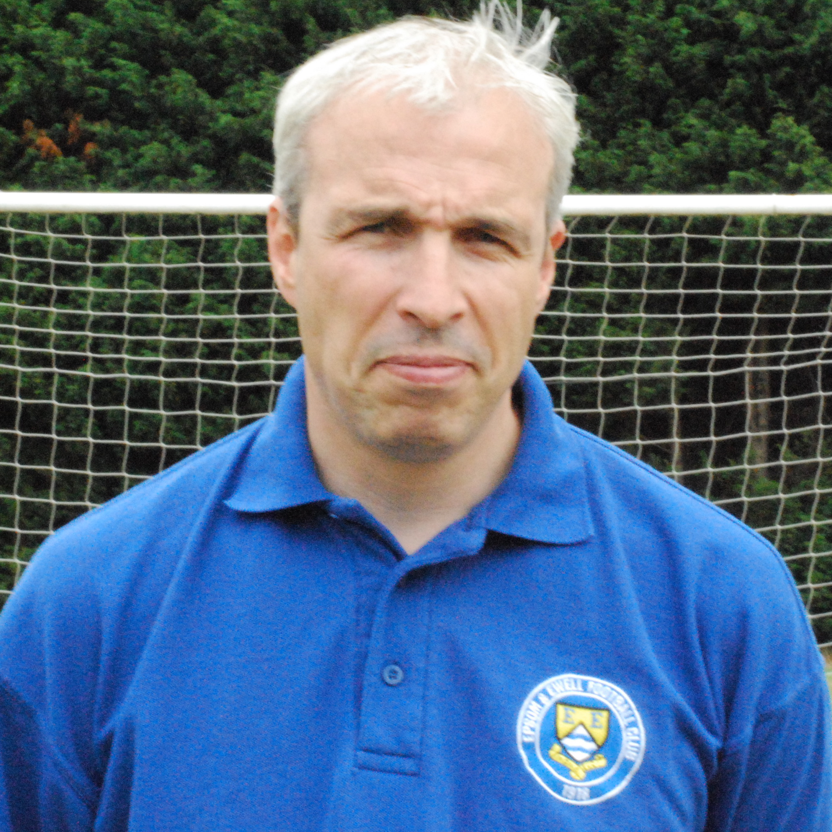
Today we hope to be welcoming back two of Epsom’s best recent players in striker Dale Marvell, and goalkeeper Paul Borg. Both on their day are top quality players who have been missed at the club, but if I’m being honest I hope they both have a stinker this afternoon!

On the pitch our performances have improved a lot lately and last Saturday I thought we deserved at least a point against one of the league favourites in Windsor. Yet again we had the opposition Manager complimenting us on the quality of our football, but yet again we finished a game with no points to show for our efforts, (although to be fair the lads did give everything).

On the injury front, goalkeeper Adrian Jones and midfielder Ben Hayward should be available for selection in a day or two, but Nathan Ayling will have to wait a bit longer as he's still recovering from a groin injury.

Don’t forget this coming Tuesday we entertain Sutton Utd in the Surrey Senior Cup and we hope you can come down to support the lads.

Enjoy the game.

Lyndon

Did You Know?
Saturday’s defeat at Windsor was watched by an official attendance of 213 (even though they announced 208 on the day!)

But when did an attendance of this size last watch us? Well, the answer is way back on 30th November 2004 when 255 witnessed our 0-4 Surrey Senior Cup defeat at Woking. Funny really, as I recalled thinking that the attendance was a poor one at Kingfield that evening!

Latest Results and Fixtures
F.A. Vase Second Round – Saturday 19th November
Egham Town | 0-1 | Cowes Sports
Hanworth Villa | 3-1 | Deal Town
Lancing | 2-1 | Guildford City
South Park | 3-0 | Fawley
Combined Counties League – Saturday 19th November
Camberley Town | 4-0 | Mole Valley SCR
Chessington & Hook United | 1-2 | Ash United
Colliers Wood United | 1-2 | Dorking
Cove | 1-5 | Horley Town
Epsom & Ewell | 2-1 | Croydon
Farnham Town | 2-0 | Banstead Athletic
Raynes Park Vale | 2-4 | Wembley
Surrey Senior Cup Second Round – Monday 21st November
Ash United | 4-1 | Crystal Palace
Surrey Senior Cup Second Round – Tuesday 22nd November
Banstead Athletic | 1-6 | Godalming Town
Mole Valley SCR | 0-1 | Chipstead
Combined Counties League – Tuesday 22nd November
Badshot Lea | 1-1 | South Park
Cove | 0-3 | Chessington & Hook United
Farnham Town | 1-1 | Windsor
EL Records League Cup Third Round – Wednesday 23rd November
Guildford City | 2-2+ | Wembley
Guildford City won 5-4 on penalties
Combined Counties League – Wednesday 23rd November
Croydon | 1-1 | Hanworth Villa
Combined Counties League – Saturday 26th November
Ash United | 0-4 | Guildford City
Badshot Lea | 1-0 | Colliers Wood United
Banstead Athletic | 2-2 | Raynes Park Vale
Croydon | 1-1 | Farnham Town
Hanworth Villa | 1-0 | Chessington & Hook United
Horley Town | 0-2 | Dorking
Mole Valley SCR | 3-0 | Cove
Molesey | 0-3 | Sandhurst Town
South Park | 2-1 | Egham Town
Wembley | 0-2 | Camberley Town
Windsor | 1-0 | Epsom & Ewell
Surrey Senior Cup Second Round – Tuesday 29th November
Carshalton Athletic | 5-1 | Raynes Park Vale
Dorking | 2-4 | Leatherhead
Egham Town | 0-4 | Ashford Town (Middx)
South Park | 2-1 | Kingstonian
Whyteleafe | 4-0 | Chessington & Hook United
EL Records League Cup Second Round – Tuesday 29th November
Badshot Lea | 3-1 | Mole Valley SCR
Combined Counties League – Tuesday 29th November
Banstead Athletic | p-p | Wembley
Horley Town | 0-0 | Hanworth Villa
Combined Counties League – Wednesday 30th November
Guildford City | 2-0 | Colliers Wood United
F.A. Vase Third Round – Saturday 3rd December
Hanworth Villa | V | Herne Bay
South Park | V | Diss Town
Combined Counties League – Saturday 3rd December
Badshot Lea | V | Windsor
Camberley Town | V | Ash United
Colliers Wood United | V | Molesey
Cove | V | Croydon
Dorking | V | Wembley
Epsom & Ewell | V | Egham Town
Farnham Town | V | Horley Town
Guildford City | V | Banstead Athletic
Sandhurst Town | V | Raynes Park Vale
Surrey Senior Cup Second Round
Tuesday 6th December
Epsom & Ewell | V | Sutton United
Combined Counties League – Tuesday 6th December
Mole Valley SCR | V | Banstead Athletic
Raynes Park Vale | V | Croydon
South Park | V | Guildford City
Combined Counties League – Saturday 10th December
Chessington & Hook United | V | Epsom & Ewell
Cove | V | Farnham Town
Croydon | V | Ash United
Egham Town | V | Colliers Wood United
Guildford City | V | Mole Valley SCR
Hanworth Villa | V | Dorking
Horley Town | V | Badshot Lea
Molesey | V | Banstead Athletic
Raynes Park Vale | V | Camberley Town
South Park | V | Windsor
Wembley | V | Sandhurst Town
EL Records League Cup Third Round – Tuesday 13th December
Raynes Park Vale |  | Farleigh Rovers

From behind the goal
Epsom & Ewell 2-1 Croydon – Combined Counties League
Saturday 19th November 2011

Last season the Salts didn’t win a single league game on a Saturday at the Moatside, yet this year they already have three on the back of another hard-working performance against an improved Croydon team.

The back four was altered again due to Jamie Hatfield’s one match suspension, so Jamie Summers moved over to left back while Anthony Panayi slotted back in alongside Alex Rodrigues, with Paul West on the right. And it was West who made many headlines this day. Although the main story was about Mark Jarman, who scored both goals on the day for us, it was also a topsy-turvy day for our right-back who had a major involvement in a goal at each end.

In all honesty we were a bit slow out of the blocks and in the first minute a right wing cross should have been headed in by the visiting striker, but his effort was wide from close range. It was a let off that the Trams would live to regret. Although they were in the ascendency for a while after this, they would not get a better chance all day, and we took the lead in the 17th minute.

Dave Francis had been unable to get the better of their young speedy left back, but his perseverance won him another chance and he sent a dangerous low cross into the box. The keeper had to go for it, and got a good hand on the ball, but unfortunately for him, the ball then hit the incoming Jarman and dribbled slowly towards the goal line, just crossing it before the defender could hack in clear. Yes, the ball did hit our striker’s arm, but there was absolutely nothing he could do about it, and it was a perfectly legitimate, if somewhat fortunate way to take the lead.

It was nearly 2-0 soon afterwards as an Epsom cross came in from the left wing and the clearance was horribly sliced straight towards the roof of the net, but the keeper made an alert block. Sam Robinson tried his luck in the 23rd minute from a similar position to his opening goal against South Park but dragged his shot wide. On the half hour we were cut apart and Dan Coles made a fine save to his right. Unfortunately five minutes later he would be picking the ball out of his net anyway, courtesy of another penalty, conceded by West in the 35th minute. Now we have clear evidence to suggest that the challenge was outside the area and the spot kick should not have been given, but it was a rash and unnecessary challenge, coming only seven days after his foul also gave South Park a penalty consolation, and it was the ninth our boys have conceded already this season.

As the second half started, we turned the heat up on our opponents a bit. Summers was unlucky with a low shot that deflected wide off Jarman, while Robinson also made a great run to the touch line but his pull back just eluded Francis. We went ahead again in the 55th minute, when a cross from West was headed in by an unmarked Jarman, but that doesn’t tell the full story, as West’s cross from right out on the touchline could not have been better placed had he picked it up and given it to his team mate. It was Premier League quality and tighter marking wouldn’t have made a difference as our centre forward buried the header, with the ball just flicking the cross bar on the way in.

As we passed the hour mark, the gaps we had been finding began to close and the game became more even, but the damage was done. We had our lead and held on fairly comfortably, with few goalmouth incidents at either end.

From behind the goal
Windsor 1-0 Epsom & Ewell – Combined Counties League
Saturday 26th November 2011

Under the dictionary definition of “heroic defeat” you will find a picture of our First Team, after the players dealt with almost everything Windsor could throw at us and on another day might have even taken a point from our trip to Stag Meadow.

Yet again we were forced into another defensive reshuffle as Jamie Summers was working and Jamie Hatfield was away. In came Anthony Panayi and Antony “Freddie” Myers to fill the vacancies, while Matt Smith returned to the starting line up at the expense of Dave Francis.

The first fifteen minutes were concerning as Windsor went uphill but with a strong wind behind them, and a couple of shots were just wide of the posts while Dan Coles made the first of many great saves as he blocked an unmarked header with his right hand. After weathering that storm the Salts began to scatter passes across the field and we had the opposition chasing shadows at times. In fairness, Windsor still had more possession but we had some chances. Alex McGregor sent a curling shot just over the bar from a good Smith pull back, while Mark Jarman and the keeper went up for a ball, which came out to Sam Robinson but his volley was over the bar.

A poor Myers back pass was intercepted and the ball was struck just over the bar as a result, while another shot deflected just wide of Coles’ right hand post, but the game became more even as we reached half time and as I switched to the other end of the ground for the second half, you could hear the start of a few mumblings amongst home supporters.

They could have become regular moans if we had taken advantage of a couple of good positions early in that period, but the final ball never arrived, and the home side took the lead in the 53rd minute when O’Toole cut inside his man and his shot gave Coles no chance as the ball zipped just inside the post. We had no alternative but to attack a bit more at this point, and we gave it a good try. Robinson produced a good run but his shot pinged against the far post and out for a goal kick in the 63rd minute. Three minutes later Smith’s shot was on target and was tipped over the bar by a stretching keeper.

Inevitably though, when you attack, the price you pay is to leave yourselves a bit more open at the back and Coles was called into action on frequent occasions. We nearly conceded a comedy own goal as he made a half save of a shot although the ball was still heading towards the goal before Ali Dewar got back to save the day, but his clearance then rebounded off his keeper and out for a corner!

In the 72nd minute Coles made a fantastic save when the home striker was one on one with him, and within seconds he was there again to keep out a far post header from point blank range. Then Dewar was first to a right wing Smith cross and headed the ball back to Jarman but his goal bound volley was headed away. He just beat the defender to the second ball and was brought down in the process, but the referee was not interested, despite the offence taking place right in front of him.

Paul West made a last ditch clearance and Coles was in action once again as the game became really stretched. Windsor had a goal disallowed for offside and we nearly levelled at the end when Jarman turned his man, but sliced his shot wide and on his debut, substitute Jamie Cottee had a goal bound shot blocked away in the final seconds of a very entertaining game, where both teams played their part.

Club History - 3rd December
Date | Day | Competition |  | Opponents |  | Scorers
03/12/32 | Sat | London League | A | Carshalton Athletic | 2-4 | Williams (2)
03/12/49 | Sat | Corinthian Memorial Shield 1 | H | Chesham United | 1-2 | Wright
03/12/55 | Sat | Corinthian League | H | Maidstone United | 5-0 | Blazey (2), Webb,  Berry, Hermitage
03/12/60 | Sat | Corinthian League | A | Wokingham Town | 1-1 | Flynn
03/12/66 | Sat | Athenian League 2 | A | Marlow | 2-7 | Williams, Spriggs
03/12/77 | Sat | Surrey Senior Cup 4q | A | Horley Town | 4-1 | Coombe (pen), Butler,  Tuite, Parkin
03/12/83 | Sat | Isthmian League 1 | A | Cheshunt | 2-0 | Hill (2)
03/12/85 | Tue | FA Trophy 3q rep | A | Grays Athletic | 2-3+ | Tuite, Kidd
03/12/88 | Sat | Isthmian League 2s | A | Chertsey Town | 0-1
03/12/94 | Sat | Isthmian League 3 | H | Kingsbury Town | 3-3 | Meredith, O'Connor, Miller
03/12/05 | Sat | Assoc Members Trophy Group | H | Dorking | 0-1
Seasons in the Past
90 years ago – Epsom Juniors
03/12/21 | Sat | Sutton & District League Premier | A | Epsom Brotherhood | 0-2
80 years ago – Epsom Town
05/12/31 | Sat | London League | A | Hendon | 2-1 | Williams, Graves
70 years ago – Epsom Town (war time)
06/12/41 | Sat | South Eastern Combination | A | Sutton United | 2-3 | Ottway, Brown
60 years ago – Epsom F.C.
01/12/51 | Sat | Corinthian League | A | Maidstone United | 0-2
50 years ago – Epsom & Ewell F.C.
02/12/61 | Sat | Surrey Senior Cup 3q | H | Camberley Town | 6-3 | Punter (3), Millard, Mead, Kenyon
40 years ago – Epsom & Ewell F.C.
04/12/71 | Sat | Athenian League 2 | A | Windsor & Eton | 1-4 | Blake
30 years ago – Epsom & Ewell F.C.
05/12/81 | Sat | Isthmian League 1 | A | Maidenhead United | 4-1 | Tuite (3), Hill
20 years ago – Epsom & Ewell F.C.
30/11/91 | Sat | Isthmian League 3 | H | Petersfield United | 3-1 | Meyer, Webster, o.g.
10 years ago – Epsom & Ewell F.C.
08/12/01 | Sat | Isthmian League 3 | A | Wingate & Finchley | 2-0 | Huckle, Stevens

Notes for 3rd December
90 years ago today Epsom Juniors made the tiny journey across town to the Brickfield Ground, the new home of Epsom Brotherhood, the best team in the area. They were a new club too, but had stolen a march on the Juniors by managing to secure a private ground on the site of the old Stone’s Brickworks in East Street, near to where the Kiln Lane Industrial Estate now is. The Juniors came unstuck with a 2-0 defeat, but this season would be the last one where the youngsters would play second fiddle, as they were soon to move to Horton Hospital Grounds and in 1922/23 would defeat almost all in front of them as the club began their way up the levels, while the Brotherhood would not last much longer.

80 years ago this week Hendon were defeated 2-1 in a London League match, thanks to goals from Billy Williams and Leslie Graves. This was not the Hendon that is in existence today, they were formed as Golders Green. This team was the original Hendon, and played at the Welsh Harp Ground in Kingsbury, near the reservoir.

70 years ago this week Sutton United defeated Epsom Town 3-2 at Gander Green Lane in a wartime South Eastern Combination match. It was a well-contested match but a fair result. Bobby Gill played for us this day, while his younger brother Maurice played against him. It was level at half time but Hugh “Tipper” Pratt, scored his second goal of the game and Sutton then extended their lead further, before Judge pulled one back with twenty minutes remaining, but we were unable to score again.

55 years ago today Maidstone United were thumped 5-0 at West Street. Quite a good result you might think, considering we had been bottom of the league the previous season, but when you bear in mind that Maidstone would be League Champions this term, it was quite a special score line. Bill Blazey scored twice, while Johnny Berry, Dave Hermitage and Ron Webb got the others, as we finished a much more creditable fifth this season. (see programme right)

50 years ago this week Camberley Town were bashed up 6-3 in a Surrey Senior Cup match. Jim Punter scored three times as the Blues booked a home tie in the next round with the mighty Dulwich Hamlet.

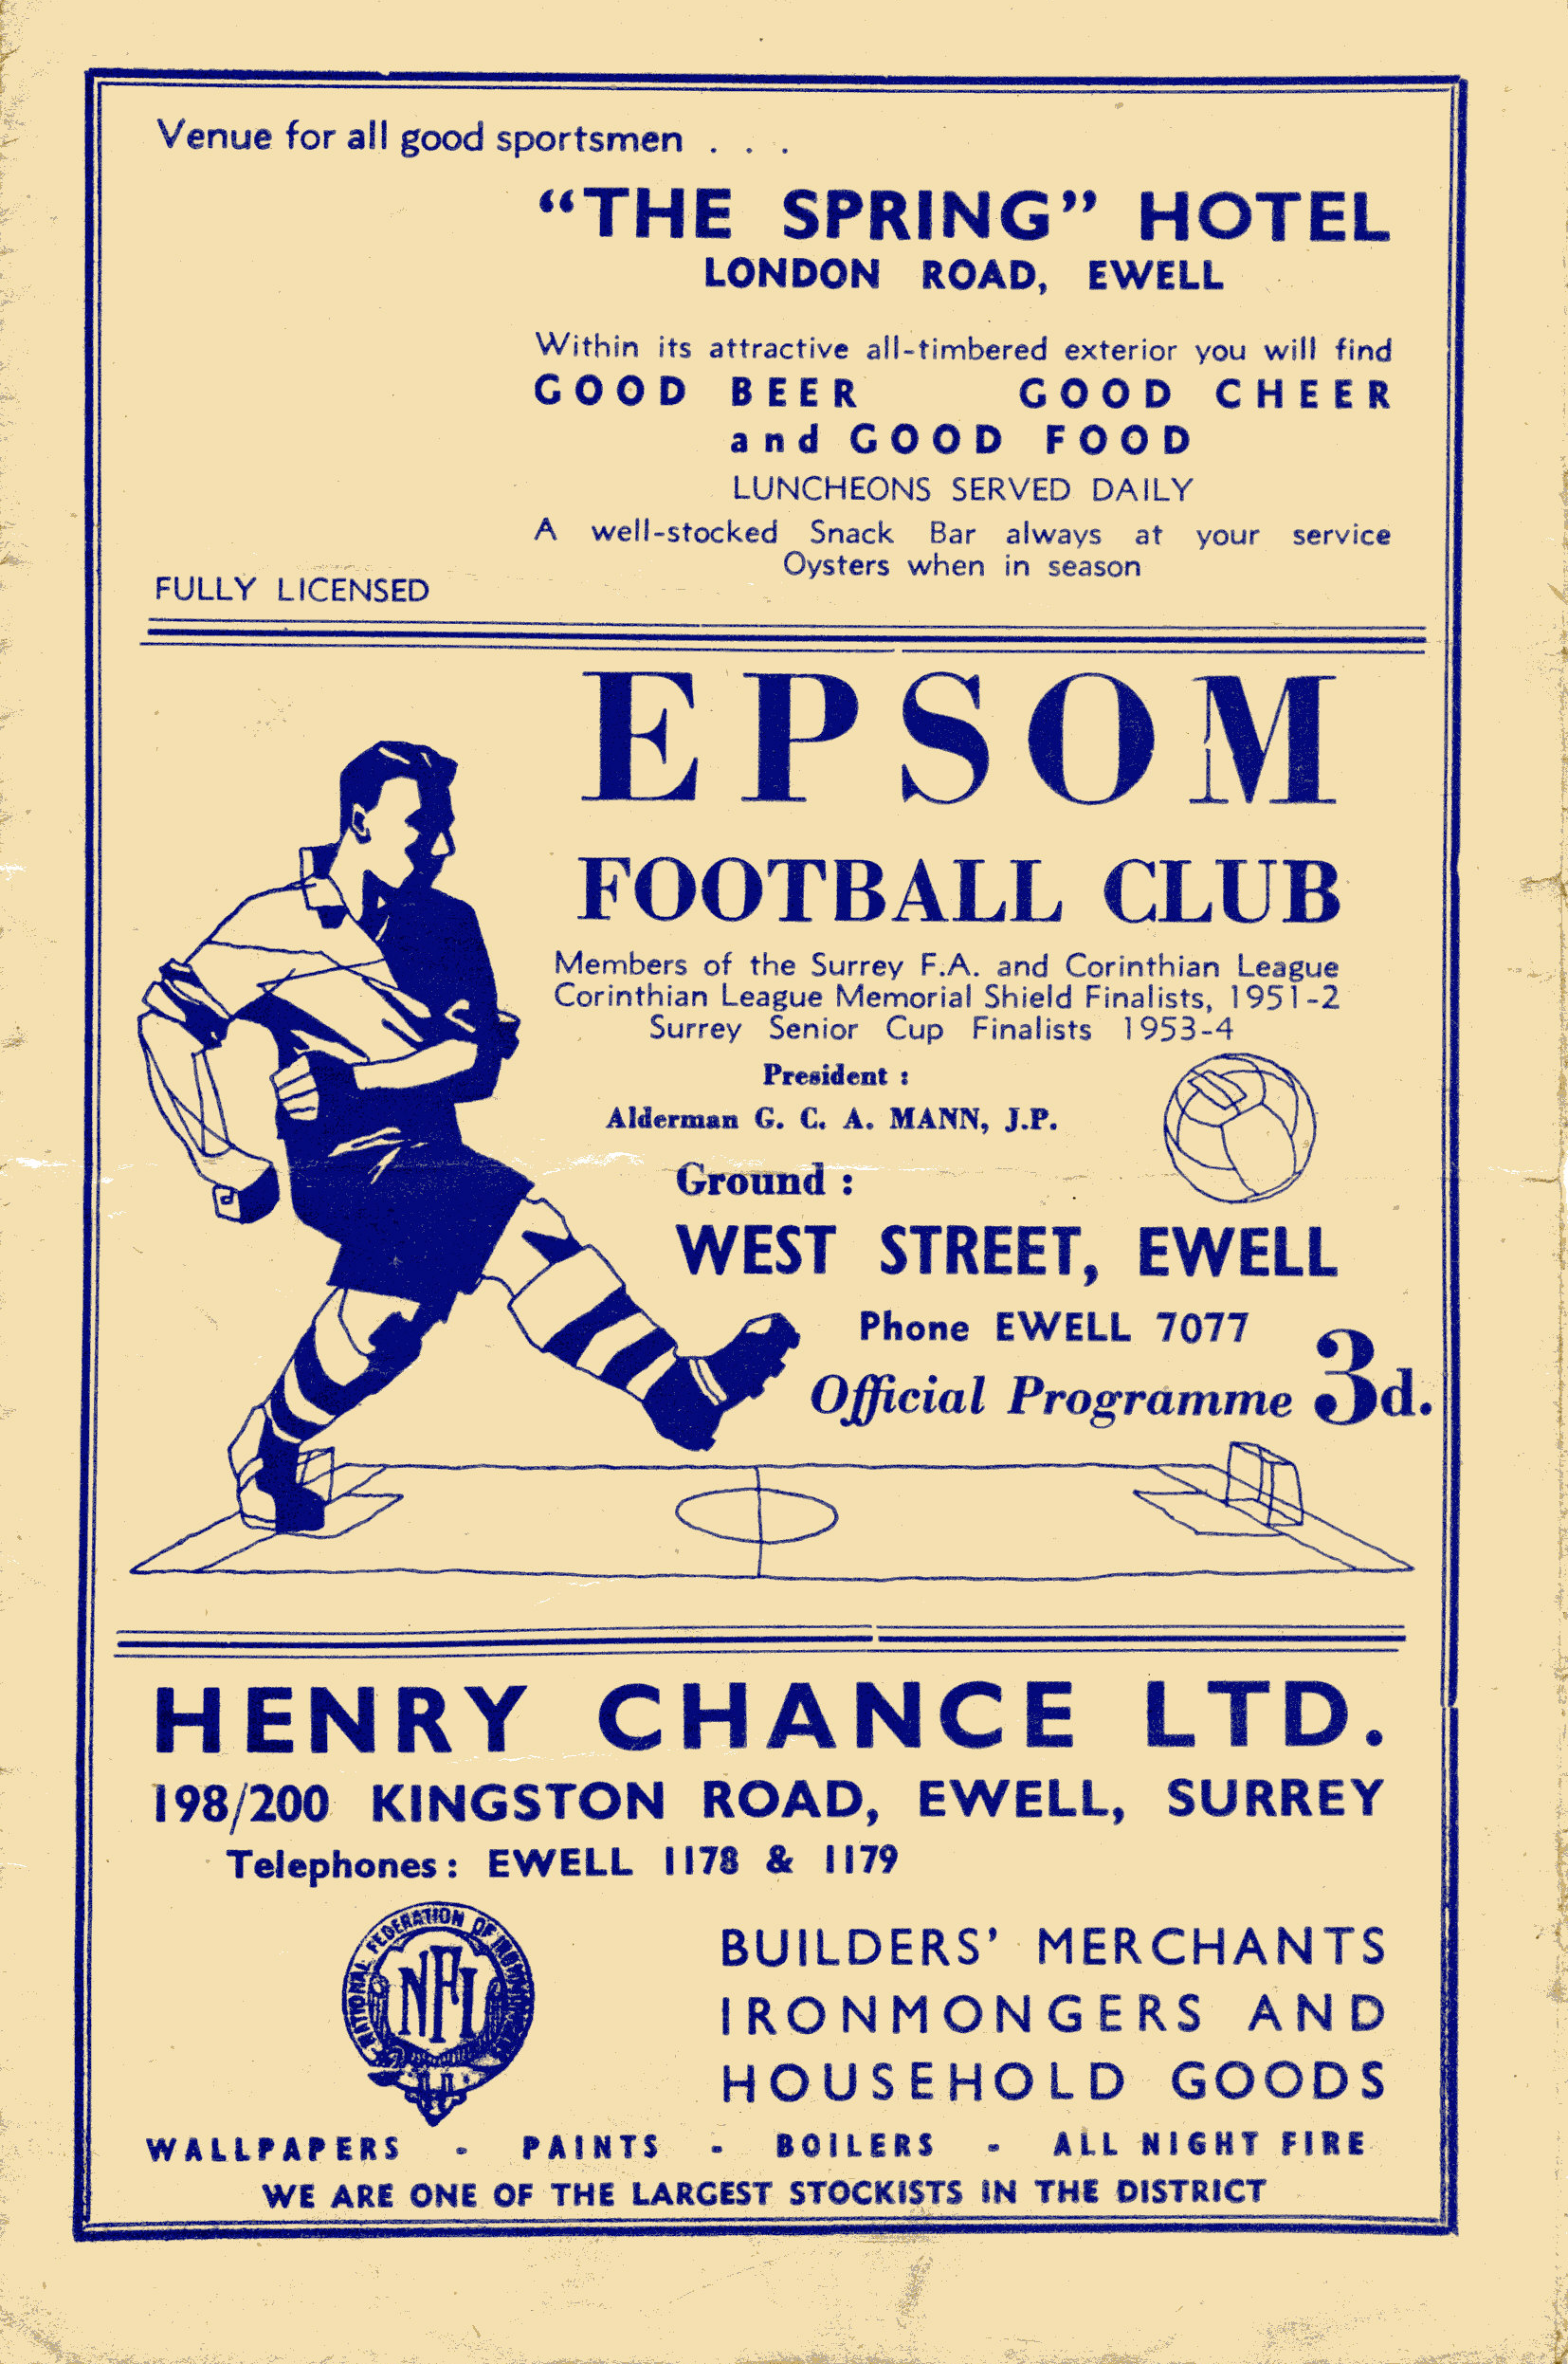
30 years ago this week Epsom & Ewell secured a very good 4-1 win at Maidenhead United this day. Tommy Tuite got a hat trick, but I can still recall the press headline that read “Sweet and Sour Tommy” as he had also been a bit greedy at times with teammates waiting. The team coach I was on arrived at the game nice and early and I spent some time in the old wooden stand there, which was destroyed by fire a few years later. To this day York Road still has its main stand on the other side of the ground.

26 years ago today we were edged out of the F.A. Trophy by lower division Grays Athletic. This was such a depressing result, as we were having a poor season and would go down, but filled with memories of our good Trophy run just a few years before, we had hoped for more progress here. We had destroyed Kingstonian 5-1 and Basingstoke Town 3-0 in earlier rounds only to be held 2-2 at West Street and have to travel to Essex for a replay. With a second replay looming we were edged out in extra time and Grays went on to reach the last 32 themselves instead of us.

Steve Dyke
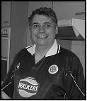

Schadenfreude, Football and the German Sense of Humour

Schadenfreude is one of those words like “joie de vivre” which has been adopted into English because there’s no direct equivalent single word that sounds as good. ”the sheer joy of being alive “ sounds OK but a little clunky but not half as clunky as “pleasure in the misfortune of others“.

I’ve written before about fan fatalism and superstition, but Schadenfreude is the other great unspoken of the football fans experience. By even writing about it I will be revealing myself to be a more small-minded and mean-spirited individual than even those who know me well would recognise, but it is there and I think I’m not alone ….

I would like to know if viewing figures reflect this but how often have you been on the cusp of what I’ll call the 10.30 Saturday Night decision. You’re dog tired - but Match of the Day is coming on. If you’re like me Chelsea, Man City or Man United losing, or a player you don’t like getting sent off will keep you downstairs rather than up. A dull week where all the top teams win guarantees an early night. What keeps the viewing figures up? You’ve guessed it, good old schadenfreude. I sometimes think when you deal with the frustrations of greedy players and agents, expensive ticket prices etc. it’s all that keeps me interested in top level football.

The chance to see the rich and powerful, and one’s Lords and Masters fall flat on their faces, and gain pleasure out of it is as old as time itself and it’s a noble tradition. A recent survey said that Homer Simpson’s exclamation of “doh” was probably one of the first proto words – another one from the University of Nowhere’s media manipulation studies department. I would like to contend it is probably “aaaargggh”. To test this, just wait and see if a referee falls over today and listen to what happens. It’s primeval.

So in enjoying the misfortunes of others I am merely expressing my deep anthropological heritage and I enjoy it. It only becomes a problem when engaging in the modern phenomenon of watching football with girls.

So I make no bones about it – and it will not make me popular in these parts – I don’t like Chelsea. Never have. It’s not some new fangled thing that’s come up since they came into money, although I have to admit it’s given me a whole new lot of reasons not to like them. Why do the cameras always turn to Abramovich when he’s at the game to see how he’s reacting –doh!

So you might be watching, say a European Cup Final – that’s gone to a penalty shoot out. Your least favourite Chelsea player may have had the

chance to win that European Cup with a penalty. He slips and hits the post and collapses to the ground in tears.

Of you and your wife, which of you – (a) Whoops round the room punching your fists in the air going aaarghhh and laughing like a maniac.

(b) Says, “the poor man, oh I feel so sorry for him.”

So it’s clear who is a nice person all of the time, and who can be affected by what football can do to them. To any Chelsea fans still reading this article I ask you to look deep within your souls and honestly answer me if the scenario had played itself out the other way that you would not have done the same. To be fair to myself I was laughing my head off when Cristiano Ronaldo tried a fancy pants penalty and missed in that very same shoot out.

I started thinking about my long dormant German ‘A’ level when watching one of the recent debates about Europe. A very elderly, very Eurosceptic Lord got up and among his remarks was,

“Of Course the Germans are renowned for having no sense of humour “

I thought we put people into the House of Lords for their wisdom and expertise. This remark got a murmur of approval from those still awake in the chamber. I just went doh.

The Germans do have a great sense of humour. I’ve watched a number of German films round at Paul Marshall’s where the bloke with the moustache never quite gets round to mending the young lady’s dishwasher!

The best example though is in music. By the magic of You Tube I’ve been able to catch up with all the German New Wave that sprang up when I was doing my ‘A’ Level in the early 1980’s. Previous to this, all hits in Germany were either British or American and sung in English.

One of the Pioneers singing in German were a Rock Group called BAP, who took the localist agenda even further by singing in Kolsch, the local dialect for Cologne. Their lead singer is Wolfgang Niedecken, who sports a classic German mullet that would have Gerry Francis envious.

BAP’s signature hit is called “Verdammt Lang Her” (a damn long time ago). Twenty years later a German punk band “Die Toten Hosen“ (The Dead Trousers) released a mickey take of this song played about three times as fast called Verdammt Lang Haar (Damn Long Hair). I’ve just seen a video of them playing it dressed as Santas, and one guitarist revealed himself as – Wolfgang Niedecken of BAP.

Imagine Bruce Springsteen appearing on a Greenday track? No sense of humour, my back passage!

It only remains for me in a true spirit of schadenfreude to wish Notts County all the luck in the world for tomorrow’s game – oh and to us for Tuesday.

First Eleven Appearances - (max 24)
Name | Debut | 2011/12 |  |  |  | Career Totals
Name | Debut | App | Sub | Total | Goals | App | Sub | Total | Goals
AYLING Nathan | 15/11/08 | 10 | 3 | 13 | 1 | 10 | 10 | 20 | 1
BEDJ BEDJ Ramzi | 08/08/09 | 3 | 3 | 6 | 0 | 61 | 6 | 67 | 18
BURNS Robbie | 14/08/07 | 12 | 2 | 14 | 6 | 163 | 6 | 169 | 97
COLES Dan | 06/08/11 | 18 | 2 | 20 | 0 | 18 | 2 | 20 | 0
COTTEE Jamie | 26/11/11 | 0 | 1 | 1 | 0 | 0 | 1 | 1 | 0
DEWAR Ali | 29/10/11 | 4 | 1 | 5 | 0 | 4 | 1 | 5 | 0
DOWNS Carl | 17/09/11 | 9 | 3 | 12 | 0 | 9 | 3 | 12 | 0
FRANCIS Dave | 06/08/11 | 15 | 5 | 20 | 6 | 15 | 5 | 20 | 6
GROBLER Dre | 21/08/11 | 9 | 3 | 12 | 0 | 9 | 3 | 12 | 0
HARMSWORTH Matt | 10/09/11 | 0 | 3 | 3 | 1 | 0 | 3 | 3 | 1
HATFIELD Jamie | 11/11/06 | 10 | 2 | 12 | 0 | 142 | 9 | 151 | 5
HAYWARD Ben | 07/03/07 | 2 | 3 | 5 | 0 | 166 | 17 | 183 | 9
HOADLEY Harry | 27/08/11 | 1 | 0 | 1 | 0 | 1 | 0 | 1 | 0
JARMAN Mark | 08/08/09 | 20 | 1 | 21 | 11 | 52 | 18 | 70 | 28
JONES Adrian | 06/08/11 | 6 | 0 | 6 | 0 | 6 | 0 | 6 | 0
McGREGOR Alex | 08/08/09 | 18 | 4 | 22 | 2 | 80 | 30 | 110 | 9
MOON James | 16/08/11 | 3 | 1 | 4 | 0 | 3 | 1 | 4 | 0
MYERS Antony | 23/12/06 | 9 | 3 | 12 | 2 | 32 | 4 | 36 | 5
ORDUNO Inaki | 06/08/11 | 4 | 1 | 5 | 1 | 4 | 1 | 5 | 1
PANAYI Anthony | 14/11/10 | 14 | 3 | 17 | 0 | 35 | 3 | 38 | 1
RICHARDS Ayden | 09/08/11 | 1 | 6 | 7 | 0 | 1 | 6 | 7 | 0
ROBINSON Sam | 22/10/11 | 7 | 0 | 7 | 2 | 7 | 0 | 7 | 2
RODRIGUES Alex | 05/04/07 | 16 | 2 | 18 | 0 | 228 | 2 | 230 | 2
ROWE Steve | 27/08/11 | 5 | 1 | 6 | 0 | 5 | 1 | 6 | 0
SIEFERS Tom | 29/08/11 | 2 | 3 | 5 | 0 | 2 | 3 | 5 | 0
SMITH Matt | 08/08/09 | 15 | 3 | 18 | 3 | 69 | 23 | 92 | 5
SUMMERS Jamie | 06/08/11 | 22 | 0 | 22 | 3 | 22 | 0 | 22 | 3
WALSHE Sonny | 16/08/11 | 2 | 1 | 3 | 0 | 2 | 1 | 3 | 0
WEBBER Richard | 31/01/09 | 1 | 2 | 3 | 0 | 48 | 9 | 57 | 2
WEST Paul | 17/08/10 | 19 | 2 | 21 | 1 | 44 | 9 | 53 | 2
WOODWARD Chris | 06/08/11 | 7 | 1 | 8 | 1 | 7 | 1 | 8 | 1

Alan Carter’s 9 at Half Time – Quiz 11

Al’s 9 at half time – Quiz 11

For those of you looking for something to do whilst you sip your half time “cuppa” and wait for the action to resume why not have a go at my 9 at half time quiz?

Even if you don’t know the answers at least you’ll end up with a juicy tit bit to tell your mates down the pub.

1. Which manager first appointed David Beckham as England captain?

2. Who was the subject of the first £2m football transfer between English clubs?

3. What did all of these players win between 1995 and 1999: Jurgen Klinsmann, Eric Cantona, Gian Franco Zola, Dennis Bergkamp and David Ginola?

4. Which current Combined Counties Premier League side play at Oak Farm?

5. Mark Jarman and Kyle Hough were Epsom and Ewell’s top scorers in all competitions last season. How many goals did they score between them?

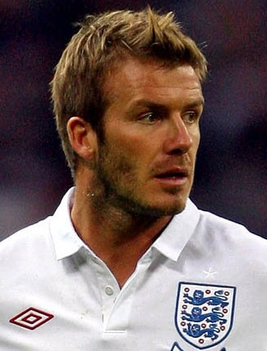
6. Which past England Captain is the only player in English football to have captained an English Football League-winning club in three different decades?

7. Who broke his neck in the 1956 F.A. Cup Final?

8. Current Combined Counties Premier League side Raynes Park Vale was formed following the merger of Raynes Park and Malden Vale. In what year was this?

9. Which Argentine player has scored the most goals in FIFA World Cup Finals tournaments?
Answers on page 31 – I got 4 – dense Ed!

This page for appearances spreadsheet (centre pages)

This page for appearances spreadsheet (centre pages)

Player Sponsorship
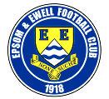 |     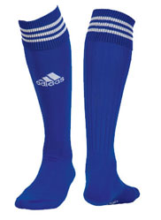  Please Sponsor one of our players for £40.00.  Just speak to any Committee Member.
Nathan Ayling | Peter Coles
Ramzi Bedj Bedj | Steve Davies & Gary Ellis
Robbie Burns | Pizza2Go –  716 London Road, North Cheam 0208 6442211
Dan Coles | Joe Hagan P.G.A. Golf Pro – 07973 264151
Ali Dewar | ID & JD Services
Carl Downs | Mike and Janette Summers
Aaron France
Dave Francis | Paul Marshall & Dougie Burns
Jamie Hatfield | Pete Lumm
Ben Hayward | Geoff Dyke
Mark Jarman | Up and Out Lofts Ltd

Adrian Jones
Alex McGregor | John Bonner
James Moon
Antony “Freddie” Myers | Tony Jeffcoate
Inaki Orduno
Anthony Panayi | The Boys behind the goal
Ayden Richards
Sam Robinson | Geoff and Arnold Pye
Alex Rodrigues | Pete Beddoe
Tom Siefers
Matt Smith | The Jarman Family
Jamie Summers | Dave Ellins
Sonny Walshe
Paul West | Someone Has To Ltd!
Lyndon Buckwell | Darryl Hatfield
Tony Coombe
Glynn Mandeville | Mark Jarman
Ken Jones
Tony Knight | Paul West

This Season’s Match Sponsors
Fixture | Date | Match Sponsor | Ball Sponsor
Colliers Wood United | 09/08/11 | Epsom & Ewell F.C.  Management Committee
Windsor | 13/08/11 | Richard Lambert
Croydon | 21/08/11 | Joe Hagan P.G.A. Golf Pro – 07973 264151
Guildford City | 23/08/11 | Steve Dyke
Mole Valley SCR | 27/08/11 | Tony Jeffcoate
Chipstead | 04/09/11 | Pete Beddoe | Paul Merritt
Hanworth Villa | 08/10/11 | Joe Hagan P.G.A. Golf Pro – 07973 264151
Horley Town | 25/10/11 |  | Pete Beddoe
Badshot Lea | 29/10/11 | Geoff Dyke
South Park | 12/11/11 | Gemma and Kirsty Herbert
Croydon | 19/11/11 | Mid-Surrey Mencap | Dave and Nicola Beddoe
Egham Town | 03/12/11
Sutton United | 06/12/11
Cove | 17/12/11
Raynes Park Vale | 02/01/12
Wembley | 14/01/12
Dorking | 28/01/12
Molesey | 31/01/12
Farnham Town | 11/02/12
Sandhurst Town | 25/02/12
Ash United | 17/03/12
Chessington & Hook | 31/03/12
Banstead Athletic | 09/04/12 | Tony Foster
Camberley Town | 21/04/12
For League Matches:
Match sponsorship is available for £35.00.

Match ball sponsorship is available for £20.00.

For Cup Matches:
Match sponsorship is available for £45.00.

Match ball sponsorship is available for £25.00.

Match sponsorship includes admission, programmes, advertising
and hospitality for two.

Match ball sponsorship is the same as above but just for one.

Interested? Please speak to a Committee Member now!

Youth Team Fixtures / Results 2011/12
All HOME games to be played at Grand Drive, home of Raynes Park Vale F.C.
1 | 05/09/11 | Thur | ST ANDREWS | SYL | 1-2 | Matheson
2 | 08/09/11 | Mon | Horsham | FAYC  PR | 2-1 | Smith (pen), Matheson
3 | 12/09/11 | Mon | BALHAM BLAZERS | SYL | 3-2 | Matheson, Smith (pen), Nadesan
4 | 26/09/11 | Mon | COBHAM | SYL | 4-0 | Jones, Matheson, Nadesan, Boyden
5 | 29/09/11 | Thur | Colliers Wood United | SYL | 3-2 | Matheson, Boyden, Bough
6 | 05/10/11 | Wed | Lancing | FAYC  2q | 9-0 | Smith (2, 1 pen), Bryant, Nadesan, Best, Jones, Matheson, Nevin (2)
7 | 10/10/11 | Mon | Egham Town | SMFC 1 | 0-3
8 | 17/10/11 | Mon | EBBSFLEET UNITED | FAYC 3q | 2-3+ | Jones, Smith
9 | 24/10/11 | Mon | Guildford City | SYLC 2 | 3-2 | Jones (2), Best
10 | 02/11/11 | Wed | Bedfont Sports | SYL | 5-2 | Jones (2), Nevin (2), Best
11 | 07/11/11 | Mon | LEATHERHEAD | SYL | 2-0 | Jones, Smith
12 | 10/11/11 | Thur | Crawley Down | SYLC 3 | 1-0 | Nevin
13 | 17/11/12 | Thur | St Andrews | SYL | 5-2 | ??
14 | 21/11/11 | Mon | EGHAM TOWN | SYL | 1-5 | ??
15 | 01/12/11 | Thur | Leatherhead | SYL |  | @ River Lane, Fetcham
16 | 05/12/11 | Mon | EGHAM TOWN | SYLC  QF
17 | 15/12/11 | Thur | Hanworth Villa | SYL
18 | 12/01/12 | Thur | Cobham | SYL
19 | 16/01/12 | Mon | COLLIERS WOOD UNITED | SYL
20 | 30/01/12 | Mon | HANWORTH VILLA | SYL
21 | 09/02/12 | Thur | Balham Blazers | SYL |  | @ Colliers Wood United
22 | 13/02/12 | Mon | WESTFIELD | SYL
23 | 22/02/12 | Wed | Molesey | SYL
24 | 27/02/12 | Mon | BEDFONT SPORTS | SYL
25 | 05/03/12 | Mon | Egham Town | SYL
 | tba |  | Westfield | SYL
 | tba |  | MOLESEY | SYL
 | tba |  | Farnham Town | GM 2
SYL - Southern Youth League FAYC - F.A. Youth Cup GM – Grant McLellan Youth Cup
SYLC - Southern Youth League Cup SMFC - Surrey Midweek Floodlit Cup

Southern Youth League Table
inc Wednesday 30th November | P | W | D | L | F | A | Pts | GD
Egham Town | 7 | 6 | 0 | 1 | 24 | 10 | 18 | +14
Epsom & Ewell | 8 | 6 | 0 | 2 | 24 | 15 | 18 | +9
Hanworth Villa | 10 | 5 | 2 | 3 | 38 | 27 | 17 | +11
Leatherhead | 9 | 5 | 1 | 3 | 23 | 17 | 16 | +6
Balham Blazers | 6 | 4 | 0 | 2 | 22 | 10 | 12 | +12
Molesey | 7 | 3 | 2 | 2 | 15 | 16 | 11 | -1
Bedfont Sports | 8 | 3 | 1 | 4 | 22 | 21 | 10 | +1
St. Andrews | 9 | 2 | 1 | 6 | 13 | 40 | 7 | -27
Westfield | 6 | 2 | 0 | 4 | 12 | 14 | 6 | -2
Cobham | 8 | 1 | 2 | 5 | 18 | 29 | 5 | -11
Colliers Wood Utd | 6 | 0 | 1 | 5 | 8 | 20 | 1 | -12

Southern Youth League Cup
First Round
Balham Blazers | 3-3+ | Three Bridges
Balham Blazers won 3-0 on penalties
Second Round
Egham Town | 12-1 | Sandhurst Town
Cove | 0-6 | Godalming Town
Bedfont Sports | 9-2 | Horley Town
Dorking | 2-0 | Leatherhead
Hartley Wintney | 0-9 | Westfield
Molesey | 6-0 | Farnham Town
Cranleigh | 0-6 | Balham Blazers
Eversley | 2-1 | Fleet Spurs
Lingfield | 2-0 | Hanworth Villa
Crowborough Athletic | 3-3+ | East Grinstead Town
Crowborough Athletic won 3-2 on penalties
Guildford City | 2-3 | Epsom & Ewell
Lewisham Borough | 1-3 | Oakwood
Colliers Wood United | 0-2 | St Andrews
Ash United | 0-4 | Redhill
Crawley Down | 2-1 | Cobham
Frimley Green Elite | 1-2 | South Park
Third Round
Westfield | 2-3 | Oakwood
Lingfield | 3-2 | Molesey
Dorking | 3-2 | Balham Blazers
Godalming Town | 0-2 | Egham Town
Redhill | 2-1+ | Bedfont Sports
Eversley | 6-3 | St Andrews
Crawley Down | 0-1 | Epsom & Ewell
Crowborough Athletic | 0-1 | South Park
Quarter Finals
Redhill | 7/12 | Eversley
South Park | 8/12 | Lingfield
Dorking | 7/12 | Oakwood
Epsom & Ewell | 5/12 | Egham Town

Every Opponent A-Z
Over the years we have played many, many different opponents. Exactly how many is a difficult question, as it all depends on your definition. Are Camberley & Yorktown different to Camberley Town, or are Epsom Town different to Epsom F.C. or Epsom & Ewell F.C.?

In my analysis I have classed them as the same team, and will work through them all from A to Z. Some we have played many times, whilst others we have met maybe just once or twice. Enjoy!

Erith & Belvedere: - Played 42 – W17 D6 L19 - F85 A96
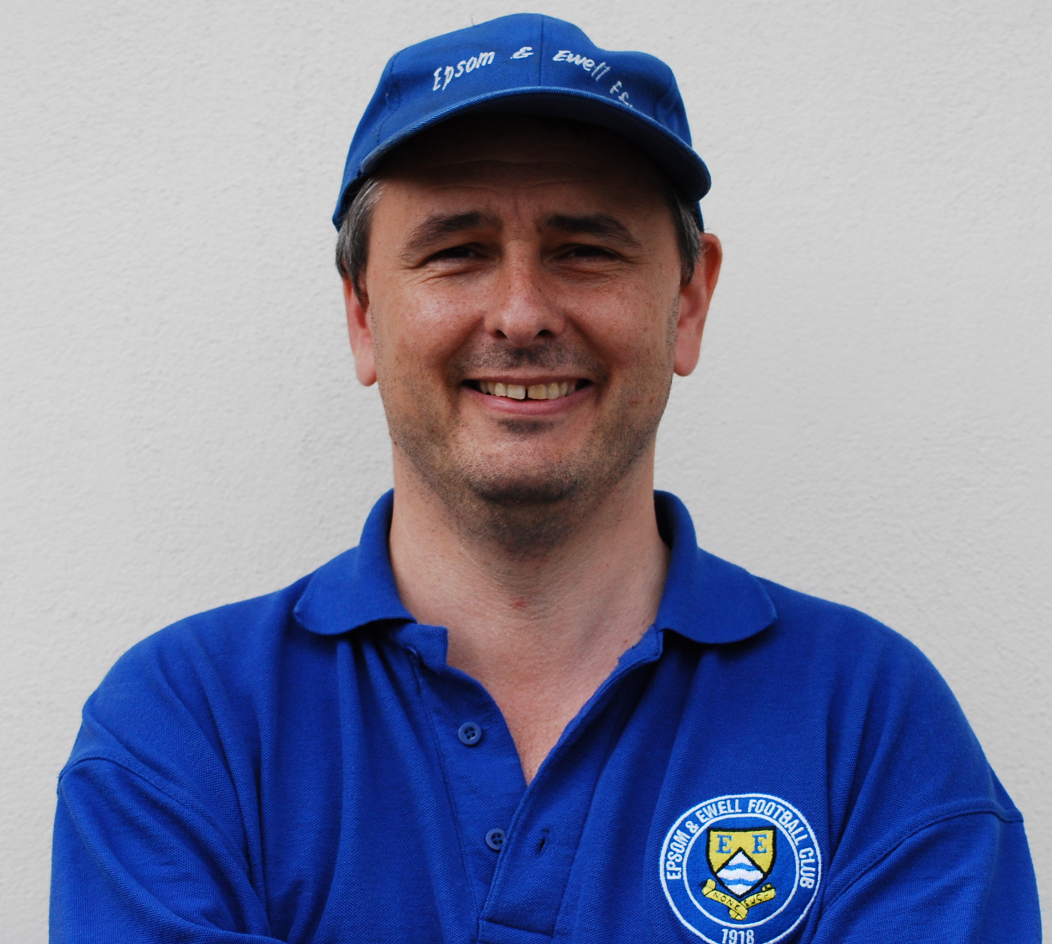
Points per Game - 1.36 - Average

The Deres were a very successful team for a very brief period before becoming just another club. They reached the Amateur Cup Final in 1938 when they lost 1-0 to Bromley in an all Kent affair, and they were a Kent League side from their formation in 1922 until the Second World War, with exception of two seasons in the London League from 1929-31, which is where we met them for the first time.

The four League meetings finished in our favour, despite our 2-1 defeat at Park View on 23rd November 1929, as we then won 4-2 at home and 4-1 away, before our final match of the sequence ended with a 1-1 home draw on 21st March 1931.

Epsom Town, who used West Street during the war once Epsom F.C. had closed down, also came up against Erith & Belvedere in the South Eastern Combination. They were however, an awesome team, never more so than in 1941/42 when they scored 253 goals in just 44 games and won the League and Cup double, only dropping one competitive point in the league. They also defeated us 14-1 at Park View the following season, yet at West Street we managed a 1-1 draw.

After the war, both became founder members of the Corinthian League. However, whilst Erith would remain in the League for its duration, Epsom Town could not survive and folded after just one term. In December of 1945 the reformed Epsom F.C. were narrowly edged out 3-4 in a friendly at West Street, but we would commence regular meetings when our boys transferred from the London League to follow their by now defunct namesakes into the Corinthian League in 1949.

From this point we would meet twice a season, every season until our relegation from the Athenian League Division One in 1965. Results were mixed, as both teams were very average over those years. Every now and then one of us would have a good season though. In 1949/50 they defeated us 3-0 home and away on their way to a third place finish, while in 1955/56 under the Doug Whitehead revolution, we won 2-0 and 5-0.

The teams got on well. So well in fact, that following the January 1953 floods that hit the Thames Estuary and killed 10,000 people, we held friendlies at West Street against just two teams, Tilbury and Erith, to raise funds for them, as they were unable to use their facilities for quite some time.

We crashed 7-1 at Park View in December 1950, but in November 1956 we won 8-1 at West Street with Johnny Bangs scoring four times. On neither occasion though did either team win the return match. We had one of our matches abandoned at West Street in January 1954, when fog came down rapidly and the match was

terminated after just 31 minutes with the score at 1-1.

Our best sequence against the Deres was in 1958/59 when we won four matches in a row, the last of which was a First Round match in the Corinthian League Memorial Shield, the only time that we ever met in the competition. This was the season that we would win the Shield for the first and only time, and the goal we conceded there in the 11th minute was the only goal we would let in during the entire competition as we recovered to win 3-1 that day and Leatherhead, Letchworth and Maidenhead were unable to breach our defences.

Conversely, our worst run against Erith & Belvedere occurred in the sixties, which were a poor decade for our club. Starting in April 1961 we lost seven in a row, although we recovered to win 2-1 at West Street in what would prove to be our first ever relegation season of 1964/65.

There was also an odd sequence in the early sixties when the Corinthian League gave us two matches against each other before August was out. In 1961/62 they were actually our opening two matches, while the following season our opening four fixtures were twice each against Erith and Uxbridge! No wonder the League closed!

There are just two more meetings to report. If you are a regular reader of this section, you will know that we met many of these regular opponents for a season on our way back up the Athenian League, following our resurrection and Wembley appearance. Erith were no exception, and we met in 1976/77 for some top flight Athenian League action, winning 5-1 at West Street, but drawing 1-1 on the first team’s final visit to Park View. They joined the Southern League shortly afterwards while we went into the Isthmian and haven’t met since.

Our Youth team went there in 1988 for an F.A. Youth Cup replay that we won 1-0 on our way to a match with Arsenal. I made my only visit there that day, and the venue had clearly seen better days. A new road had cut across one end of the ground where there had clearly been some substantial terracing, and I recall that the stand and clubhouse structure were crooked and out of shape. Regrettably they both perished in a fire in 1997, and two years later after a miserable existence in portacabins, a ground sharing agreement with Welling United came into being. Thus Erith moved from Park View to Park View Road!

They remain there to this day, but it is not a traditional type of agreement like we have. The two teams actually have joint ownership of the venue, with Erith’s facilities on one side of the ground, and Welling United’s on the other.

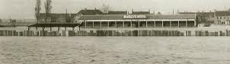

The main stand at Erith & Belvedere’s old Park View ground during the 1953 floods!

Egham Town – History
Egham Town Football Club's roots have been traced back to 1877, when, under the name of Runnymede Rovers who played in a all red strip, they were known to be playing local football. Scanty records make it difficult to trace the path of the club's fortunes, but various local locations and headquarters have been identified, including one on a site that is now under the M25, behind the petrol station in Vicarage Road. What is certain is that, as founder members of the Surrey Senior League, EGHAM F.C. were the inaugural winners of the Champions Pennant, which heralded a period of great local success. This continued until the early 1930's, including a First round appearance in the FA Amateur Cup (losing to Romford). As they did when the First World War started, the outbreak of international hostilities meant that the club slowed down; unlike the inter-war period the club played friendlies. (In the last season the club went down 0-12 at home to Woking in the FA Cup.)

EGHAM TOWN F.C. came into being after a public meeting on 9 December 1963, at which was raised a sum of seven pounds and six shillings. Originally using the (now non-existent) Council Offices Egham Urban District as changing facilities, and various methods of transport (including a truck!) to get to Tempest Road, the club developed their facilities, and after a season in the Parthenon League they were back in the Surrey Senior League.

Soon afterwards they were admitted to the Spartan League, which they won in 1967-68. Their overall strength in the Spartan led to elevation to the Athenian League, the Second Division of which was won at the first time of asking in season 1974-75. In their first season in the First Division they were runners-up, and then finished ninth before being elected to the Isthmian League.

Again, they started strongly and came fifth. It was not until 1984-85 that success of a sort came to the playing side, with a run to the 4th round of the FA Vase (still a club record), the 3rd Qualifying Round of the FA Cup and 6th place in the League Division Two. There was no follow-up of note until 1990-91 when 3rd place in the division with 87 points and 100 goals were still not enough to gain promotion.

The following season saw Mark Butler set a club record of 50 goals as the finals of the Loctite Trophy (lost 2-3 to Purfleet at Sutton United - we were 2-0 ahead) and the Surrey Senior Cup (lost 1-3 to Carshalton Athletic at Tooting & Mitcham) were reached, for the 6 years until relegation to Division 3 struck in season 1997-98. Season 2001-2 brought about a late season surge that resulted in sixth place and promotion to Division One in the reformed League set-up.

There were two notable club records; for 35 consecutive League games we did not fail to score, and leading scorer Clayton Whittle netted in ten consecutive games. The Ryman League Division One South was a wonderful adventure in our first season, with some notable victories and a final placing of 10th. Expectations for the following term were deflated with injuries to key players.

The Club were switched to the Southern League in 2004, which proved disastrous. In the 2005-06 season they played in the Isthmian League Division Two but as a result of the restructuring of non-league football they now play in the Combined Counties Football League Premier Division.

The 2011/2012 season will be, we believe a real test as the standard of the league has improved over the last couple of seasons. There are currently around six or seven sides that are strong enough to maintain a challenge this year and we firmly believe we can be one of them. Our ambition at the club is to be in the Ryman League Division 1 within the next two seasons and we believe with the current squad this is certainly achievable. We are confident we can put together a good run of form to put us in a good position by Christmas to push for the new year. Our other ambition for this year is to have some success in the cup competitions.

2nd XI Fixtures / Results - 2011/12
All HOME games to be played at Grand Drive, home of Raynes Park Vale F.C.
1 | 22/08/11 | Mon | MOLESEY | SL | 2-3 | Matthews, Hughes
2 | 27/08/11 | Sat | Thamesmead Town | SL | 1-1 | Hughes
3 | 03/09/11 | Sat | Hanworth Villa | SLC 1-1 | 3-4 | Williams, Harmsworth, Okolie
4 | 17/09/11 | Sat | South Park | SL | 2-2 | Adewale, Hagan
5 | 19/09/11 | Mon | CHESSINGTON & HOOK | SL | 4-1 | Alsanawi (2),  Gough, Pangisban
6 | 24/09/11 | Sat | Oakwood | SL | 5-0 | Binns (2), Alsanawi, Matthews, Hughes (pen)
7 | 26/09/11 | Mon | Redhill | SL | 4-4 | Adewale, England (pen), Martin, Gough
8 | 03/10/11 | Mon | LINGFIELD | SL | 2-1 | Hughes, Matthews
9 | 08/10/11 | Sat | Corinthian | SL | 6-1 | Hughes (2, 1 pen), Tilly, Flack, Dewar, Bassaka
10 | 12/10/11 | Wed | Mole Valley SCR | SL | 4-0 | Williams, Tilly, Hughes, Allan
11 | 24/10/11 | Mon | WALTON & HERSHAM | SL | 3-0 | Dewar (2), Richards
12 | 05/11/11 | Sat | Crowborough Athletic | SL | 4-2 | Hughes, Williams, Francis, Matthews (pen)
13 | 14/11/11 | Mon | COBHAM | SL | 5-1 | Francis (2), Stephens, Hughes, Alsanawi
14 | 19/11/11 | Sat | Horley Town | SL | 2-1 | England, Alsanawi
15 | 28/11/11 | Mon | HANWORTH VILLA | SLC 1-2 | 2-1 | Hughes (pen), Matheson
16 | 03/12/11 | Sat | Chessington & Hook | SL
17 | 12/12/11 | Mon | HORLEY TOWN | SL
18 | 17/12/11 | Sat | Molesey | SL
SL - Suburban League SLC - Suburban League Cup

Suburban League Southern Division Table
inc Weds 30th November | P | W | D | L | F | A | Pts | GD
Walton & Hersham | 13 | 12 | 0 | 1 | 42 | 14 | 36 | +28
Epsom & Ewell | 13 | 9 | 3 | 1 | 44 | 17 | 30 | +27
Thamesmead Town | 12 | 8 | 3 | 1 | 41 | 18 | 27 | +23
South Park | 14 | 6 | 2 | 6 | 43 | 39 | 20 | +4
Corinthian | 12 | 6 | 2 | 4 | 28 | 27 | 20 | +1
Molesey | 11 | 5 | 4 | 2 | 25 | 21 | 19 | +4
Redhill | 14 | 5 | 2 | 7 | 27 | 35 | 17 | -8
Oakwood | 12 | 5 | 0 | 7 | 27 | 35 | 15 | -8
Lingfield | 13 | 4 | 3 | 6 | 30 | 42 | 15 | -12
Chessington & Hook United | 12 | 3 | 2 | 7 | 24 | 25 | 11 | -1
Mole Valley SCR | 14 | 3 | 1 | 10 | 23 | 48 | 10 | -25
Crowborough Athletic | 9 | 2 | 3 | 4 | 20 | 23 | 9 | -3
Horley Town | 11 | 2 | 2 | 7 | 17 | 29 | 8 | -12
Cobham | 12 | 2 | 1 | 9 | 18 | 36 | 7 | -18

EL Records League Cup Draw
First Round
Knaphill | 2-3 | Epsom & Ewell
Worcester Park | 4-2 | Molesey
Camberley Town | 2-3 | Farnham Town
Bookham | 1-2 | Raynes Park Vale
Westfield | 1-1+ | CB Hounslow United
CB Hounslow won 3-2 on penalties
Croydon | 0-1 | Ash United
Windsor | 3-1 | Chessington & Hook United
Game played at Chessington & Hook
Badshot Lea | 4-1 | Frimley Green
Second Round
Dorking | 5-3 | Farnham Town
Egham Town | 5-1 | Eversley
Colliers Wood United | 5-4+ | Cove
Farleigh Rovers | 3-2 | Sheerwater
Badshot Lea | 3-1 | Mole Valley SCR
Original game abandoned due to serious player injury – new date awaited
Guernsey | 4-1 | Ash United
Windsor | 1-2 | Spelthorne Sports
Worcester Park | 7/1 | Epsom & Ewell
Cobham | 3-2 | Horley Town
Wembley | 0-0+ | South Kilburn
Wembley won 5-4 on penalties
South Park | 2-2+ | Sandhurst Town
Sandhurst Town won 4-3 on penalties
Banstead Athletic | 2-0 | Hartley Wintney
Guildford City | 2-1 | Hanworth Villa
Raynes Park Vale | 4-0 | Bedfont Sports
Feltham | 0-5 | CB Hounslow United
Staines Lammas | 3-2 | Warlingham
Third Round
Cobham | 10/12 | CB Hounslow United
Spelthorne Sports | 7/1 | Staines Lammas
Banstead Athletic | V | Worcester Park / Epsom & Ewell
Guildford City | 2-2+ | Wembley
Guildford City won 5-4 on penalties
Colliers Wood United | 14/12 | Dorking
Egham Town | 24/1 | Guernsey
Badshot Lea | V | Sandhurst Town
Raynes Park Vale | 13/12 | Farleigh Rovers

Surrey Senior Cup draw
First Round
Guildford City | 4-5 | Chertsey Town
Redhill | 2-1 | Croydon
Horley Town | 4-3+ | Camberley Town
Mole Valley SCR | 3-2 | Colliers Wood United
Badshot Lea | 1-4 | Dorking
Second Round
Tooting & Mitcham United | 1-2 | A.F.C. Wimbledon
Egham Town | 0-4 | Ashford Town (Mx)
Carshalton Athletic | 5-1 | Raynes Park Vale
Ash United | 4-1 | Crystal Palace
Banstead Athletic | 1-6 | Godalming Town
Whyteleafe | 4-0 | Chessington & Hook Utd
Epsom & Ewell | 6/12 | Sutton United
Metropolitan Police | 4-2 | Farnham Town
South Park | 2-1 | Kingstonian
Dorking | 2-4 | Leatherhead
Redhill | 1-3 | Lingfield
Woking | 2-0 | Merstham
Molesey | 20/12 | Corinthian Casuals
Chertsey Town | 6/12 | Walton Casuals
Mole Valley SCR | 0-1 | Chipstead
Horley Town | 0-4 | Walton & Hersham
Third Round
Chipstead | A | Metropolitan Police
Match 14 | B | Ashford Town (Middx)
Match 7 | C | Godalming Town
South Park | D | Leatherhead
Ash United | E | Woking
Whyteleafe | F | Carshalton Athletic
Walton & Hersham | G | Lingfield
Match 13 | H | A.F.C. Wimbledon
Quarter Finals
Match D | V | Match C
Match F | V | Match A
Match G | V | Match H
Match E | V | Match B

Supporters Player of the Match
Each week one of our players wins a bonus by being named as the Supporters Player of the Match.

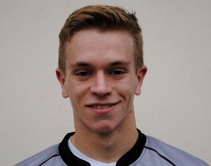
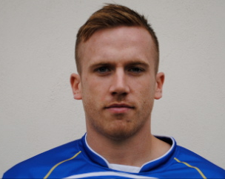
Our latest winners from the matches against Croydon and Windsor were Mark Jarman (see picture left) and Dan Coles, (see picture right). The awards so far are as follows:

09/08/11 | H | Colliers Wood Utd | CCL | 3-1 | Chris Woodward
13/08/11 | H | Windsor | CCL | 2-2 | Dave Francis
16/08/11 | A | Farnham Town | CCL | 0-0 | Alex Rodrigues
21/08/11 | H | Croydon | FAC | 3-1 | Matt Smith
23/08/11 | H | Guildford City | CCL | 2-3 | Alex McGregor
27/08/11 | H | Mole Valley SCR | CCL | 3-1 | Antony Myers
29/08/11 | A | Raynes Park Vale | CCL | 2-3 | Jamie Summers
04/09/11 | H | Chipstead | FAC | 1-2 | Jamie Summers
10/09/11 | A | Hailsham Town | FAV | 3-1 | Robbie Burns
17/09/11 | A | Sandhurst Town | CCL | 1-3 | Robbie Burns
24/09/11 | A | Ringmer | FAV | 0-2 | Dan Coles
September |  | Monthly Award |  |  | Dan Coles
01/10/11 | H | Molesey | CCL | 2-0 | Matt Smith
04/10/11 | A | Knaphill | CCLC | 3-2 | Dave Francis
08/10/11 | H | Hanworth Villa | CCL | 2-2 | Jamie Hatfield
11/10/11 | A | Dorking | CCL | 1-1 | Mark Jarman
15/10/11 | A | Ash United | CCL | 4-1 | Carl Downs
22/10/11 | A | Wembley | CCL | 1-4 | Mark Jarman
25/10/11 | H | Horley Town | CCL | 0-2 | Nathan Ayling
29/10/11 | H | Badshot Lea | CCL | 0-2 | Ali Dewar
October |  | Monthly Award |  |  | Jamie Hatfield
05/11/11 | A | Camberley Town | CCL | 0-4 | Jamie Summers
12/11/11 | H | South Park | CCL | 3-1 | Sam Robinson
19/11/11 | H | Croydon | CCL | 2-1 | Mark Jarman
26/11/11 | A | Windsor | CCL | 0-1 | Dan Coles
November |  | Monthly Award
03/12/11 | H | Egham Town | CCL
06/12/11 | H | Sutton United | SSC
10/12/11 | A | Chessington & Hook Utd | CCL

Photo of the week by Gemma Jarman
This week Gemma’s photo is an extension of our cover picture, showing all aspiring strikers how to head the ball. Mark Jarman’s header for the second goal against Croydon was as perfect as they come, so I thought you might like to see the before and after stages, including the Croydon number two appearing to celebrate our goal!
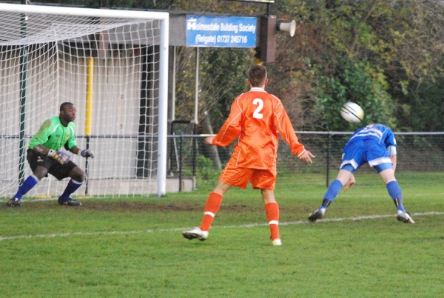
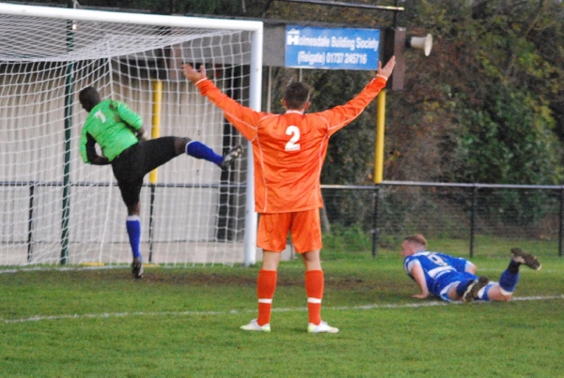
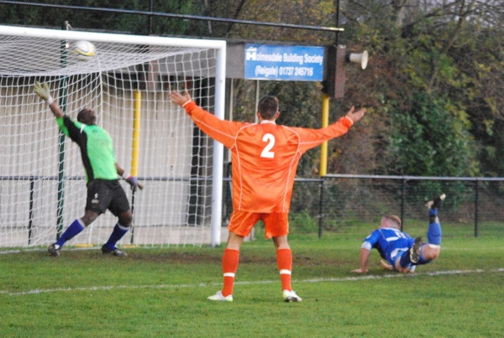
Many more of Gemma’s photos from almost every game are available on our website: Why not have a look?
http://www.pitchero.com/clubs/epsomandewellfc/

Alan Carter’s Quiz Answers – Quiz 11
1. Peter Taylor (whilst Caretaker Manager.)
2. Paul Gascoigne (from Newcastle to Tottenham in 1988).
3. English Football Player of the Year award.
4. Cove.
5. 28 (Hough 18 & Jarman 10).
6. Tony Adams.
7. Bert Trautmann of Manchester City.
8. 1995.
9. Gabriel Batistuta with 10 goals (4 in 1994, 5 in 1998 & 1 in 2002).

Combined Counties League – Premier Division
Saturday, 3rd December 2011 - Kick-off 3.00 p.m.
Epsom and Ewell  (Royal Blue & White hoops) | V |  |  |  |  | Egham Town  (All Red)
Dan Coles |  |  | 1 | 1 |  | Paul Borg
Paul West |  |  | 2 | 2 |  | Jamie Houghton
Jamie Hatfield |  |  | 3 | 3 |  | Paul Bartholomew
(capt) Alex Rodrigues |  |  | 4 | 4 |  | Wayne Noad
Jamie Summers |  |  | 5 | 5 |  | Kenneth During
Carl Downs |  |  | 6 | 6 |  | Aaron Taylor
Matt Smith |  |  | 7 | 7 |  | Lee Passmore
Sam Robinson |  |  | 8 | 8 |  | Luke Muldowney
Mark Jarman |  |  | 9 | 9 |  | Jake Galbraith
Alex McGregor |  |  | 10 | 10 |  | Matt Graves
Ali Dewar |  |  | 11 | 11 |  | Dale Marvell
Dave Francis |  |  | 12 | 12 |  | Ross White
Inaki Orduno |  |  | 13 | 14 |  | Marcus Moody
Anthony Panayi |  |  | 14 | 15 |  | William McDonald
Tom Siefers |  |  | 15 | 16 |  | Brendan Matthew
Nathan Ayling |  |  | 16 | 17 |  | Jake Joslin
Lyndon Buckwell | MANAGER |  |  |  |  | John Hamsher
Glynn Mandeville /  Tony Coombe | ASSISTANT |  |  |  |  | Colin Bartholomew / Wayne Noad
Tony Knight | COACH
Ken Jones | PHYSIO
REFEREE: J.Creswick (Byfleet)
ASSISTANTS: R.O’Sullivan (New Addington), D.Johnston (Coulsdon)

OUR NEXT FIRST TEAM MATCH AT THE MOATSIDE
Epsom & Ewell F.C.
v
Sutton United
Surrey Senior Cup – Second Round
Tuesday, 6th December 2011 – 7.45 p.m.

